**Candidate Pack**

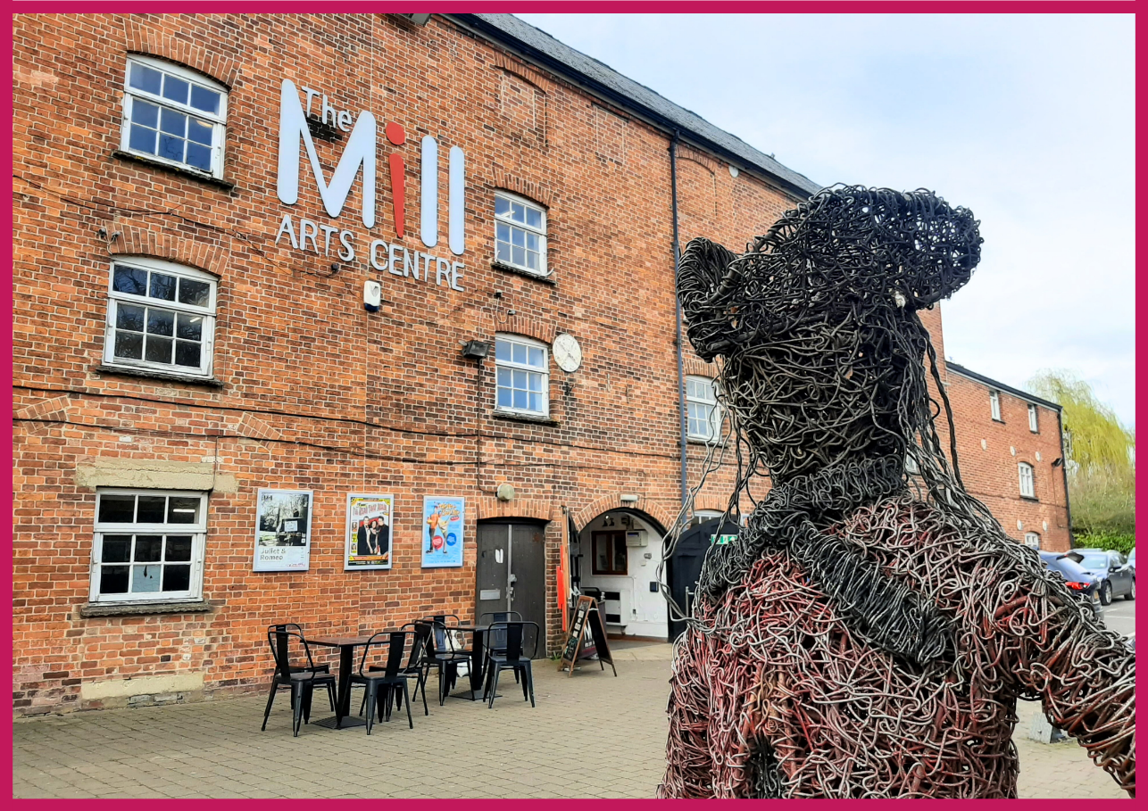**Community Engagement Officer [20 hours]**

**HELLO & WELCOME**

Thank you for your interest in this role. It’s an exciting time to join The Mill Arts Centre, as we have recently joined Arts Council England’s National Portfolio as an NPO [National Portfolio Organisation].

We are looking for a Community Engagement Officer to support in delivering on our vision at this exciting moment of change.

If you would like this information in a different format, please contact [katy.owen@themillartscentre.co.uk](mailto:katy.owen@themillartscentre.co.uk).

**ABOUT THE MILL**

The Mill is a small multi-art form venue with big ambitions. Situated in the North Oxfordshire market town of Banbury, it is the focus of cultural life as the only public arts and performance venue in the Cherwell District.

Our 237-seat theatre plays host to theatre, dance, comedy and music events which run alongside a packed creative learning and participation programme with a focus on both visual and performing arts.

Increasingly we are working outside of our building and in partnership with a wide range of organisations in Banbury and Bicester to ensure that all in our communities can experience the benefit of seeing and taking part in professionally led creative and cultural activities.

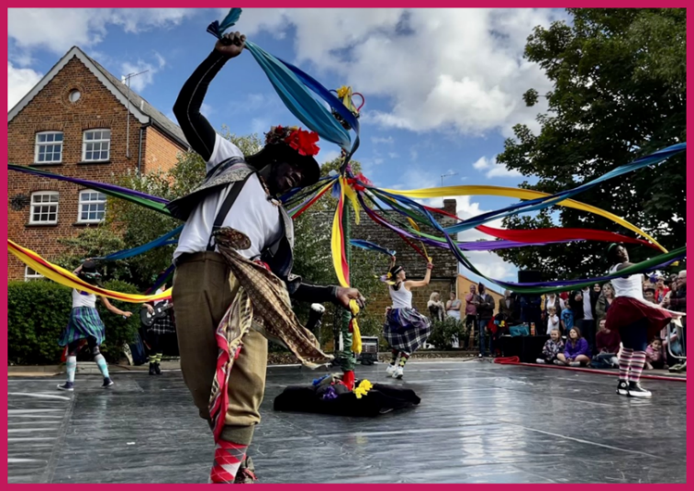As we move into our second year as a National Portfolio Organisation for Arts Council England, the successful candidate will join our ambitious team at a hugely exciting time. This is an opportunity to play a key role to support the development of The Mill in line with Arts Council’s Let’s Create strategy and secure its place as the cultural heart of the region for generations to come.

## **OUR MISSION & VALUES**

The Mill aims to be the cultural heart of Banbury and beyond. Proudly celebrating a diverse creative programme of high-quality arts experiences; telling stories that encourage everyone in our communities to learn and take part; to have fun and be inspired.

We want to be an exemplar, vibrant, indispensable Arts Centre of which Banbury is rightly proud; relevant to the whole community through a diverse programme which celebrates both taking part in and seeing first class arts and entertainment experiences.

We are much more than just a building, we will work throughout the region to support artists to create and present the highest quality arts experiences.

**Our core values are:**

* Heart and Trust
* For All
* Quality
* Creativity
* Bold and Forward Thinking

**To achieve our aims, we offer three strands of work:**

* Live events including theatre, dance, music and comedy.
* Participatory workshops, events and experiences including performing arts, visual arts and craft and holistic wellbeing.
* Visual art exhibitions.

## **ABOUT THE ROLE**

**Post:** Community Engagement Officer

**Reporting to:** Creative Director

**Contract:** Permanent, part time 0.5FTE

**Salary:** £13,197.18 @ 0.5FTE

**Place of work:** The Mill Arts Centre plus regular offsite meetings in community settings

**Hours of Work:** This role requires a degree of flexibility in order to balance office based working with the ability to meet with external groups at convenient times

## **PURPOSE OF THE POST**

As a real ‘people person’, you will develop robust and authentic relationships with community groups, partners and third-sector organisations across Banbury and Bicester. With a focus on those who have been historically underrepresented, leading to the continuous and collaborative development of a high-quality programme of live and participatory events and experiences across the Cherwell District.

## **JOB DESCRIPTION**

**Key Responsibilities:**

* Work with the Creative Director to develop the community engagement programme in line with the aims of the organisation including the development of a community engagement strategy.
* Seek to develop new audiences and increase participation through a series of venue based and outreach activities.
* Develop relationships within the local community, schools and organisations to ensure their voices are heard in planning new events and activities for The Mill
* Develop partnerships with local community organisations and educational partners to increase participation from sections of the community that are currently underrepresented both locally and within The Mill.
* Lead on the planning of community engagement projects and activities, engaging appropriately skilled and experienced practitioners to deliver workshops and creative activity where appropriate.
* Support the wider objectives of the organisation through facilitating effective discussion and consultation with community groups on future development plans and local cultural strategy.
* Contribute to our equalities, diversity and inclusion (EDI) strategy, with a focus on engaging and developing new and diverse audiences.
* Collaborate with local and national groups and organisations to raise awareness of opportunities for participation in the programme of activities.
* Work with the marketing team to develop targeted and engaging content for community engagement projects.
* To seek out opportunities to link artists with community groups and work with the Creative Director and Chief Executive to identify additional sources of income and secure funds for community engagement projects – including researching potential funders, drafting funding applications and attending meetings with relevant funders
* Collaborate effectively with colleagues and stakeholders to achieve the company’s aims and strategic objectives.
* Network and represent The Mill as required, raising the profile of the venue.
* Provide well written, engaging and timely reports for Chief Executive, Board of Trustees and key stakeholders.
* Produce timely and detailed evaluations of community engagement projects and activities for reporting to funders and stakeholders.
* Ensure that all duties are carried out in line with the organisation’s health and safety, equality, operational, data protection and financial policies and procedures
* Be fully aware of the requirements relating to the protection of young people and vulnerable adults as relating to the community development programme.

**General:**

* To undertake training as deemed necessary to support ongoing effective performance in the role
* To attend performances, meetings and events both at The Mill and off site when required to maintain up to date and effective product knowledge, build key relationships and support audience development activity

*This job description is a guide to the general nature of the work required. It is not wholly comprehensive or restrictive and can be reviewed at any time.*

## **PERSON SPECIFICATION**

|  |  |
| --- | --- |
| **ESSENTIAL** | **DESIRABLE** |
| A genuine commitment to broadening access to the arts for all, respecting all within our communities and their needs | Full UK Driving Licence |
| Evident passion for the arts and the vision and values of The Mill Arts Centre | Previous experience of creative project management, facilitation or delivery |
| Commitment to safeguarding young people and vulnerable adults | An existing network of cross-sector community contacts in the local area |
| An effective listener who enjoys meeting new people and engaging conversation |  |
| Polite, professional and diplomatic with the ability to remain calm when talking to a range of people with different needs |  |
| Excellent time and workload management with the ability to work to deadlines |  |
| Ability to appreciate the access and learning requirements of different audiences and community groups. |  |
| Open minded with the ability to spot opportunities and think outside the box |  |
| Collaborative approach to team working with a positive and forward-thinking attitude to support the wellbeing of others |  |
| Evidence of ability to work effectively with a wide range of people and organisations to build positive relationships |  |
| Self-motivated with the ability to work unsupervised |  |

## **HOW TO APPLY**

Please apply by sending the following to Emma Hiorns ([emma.hiorns@themillartscentre.co.uk](mailto:emma.hiorns@themillartscentre.co.uk)) by 12pm midday on Monday 5th August 2024:

* a completed [application form](https://www.themillartscentre.co.uk/wp-content/uploads/2023/02/MACT-Application-Form.doc)
* a cover letter explaining your interest in the position

**Interviews will take place at The Mill on 12th and 14th August 2024.**

If you have any questions or require assistance, please contact [emma.hiorns@themillartscentre.co.uk](mailto:emma.hiorns@themillartscentre.co.uk).

Good luck!