**Candidate Pack**

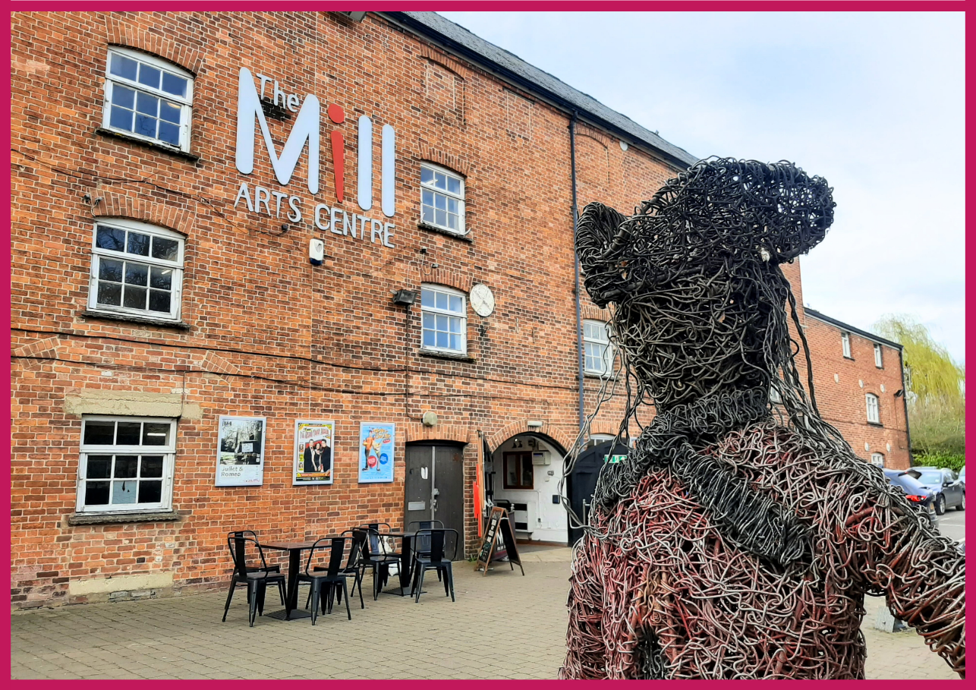**Programme Administrator (24 hours****)**

**HELLO & WELCOME**

Thank you for your interest in this role. It’s an exciting time to join The Mill Arts Centre, as we have recently joined Arts Council England’s National Portfolio as an NPO (National Portfolio Organisation).

We are looking for a Programme Administrator to support in delivering on our vision at this exciting moment of change.

If you would like this information in a different format, please contact [laura.lloyd@themillartscentre.co.uk](mailto:laura.lloyd@themillartscentre.co.uk).

**ABOUT THE MILL**

The Mill is a small multi-art form venue with big ambitions. Situated in the North Oxfordshire market town of Banbury, it is the focus of cultural life as the only public arts and performance venue in the Cherwell District.

Our 237-seat theatre plays host to theatre, dance, comedy and music events which run alongside a packed creative learning and participation programme with a focus on both visual and performing arts.

Increasingly we are working outside of our building and in partnership with a wide range of organisations to ensure that all in our communities can experience the benefit of seeing and taking part in professionally led creative and cultural activities.

Having recently been successful in our application to become a National Portfolio Organisation for Arts Council England, the successful candidate will join our ambitious team at a hugely exciting time. This is an opportunity to play a key role to support the development of The Mill and secure its place as the cultural heart of the region for generations to come.

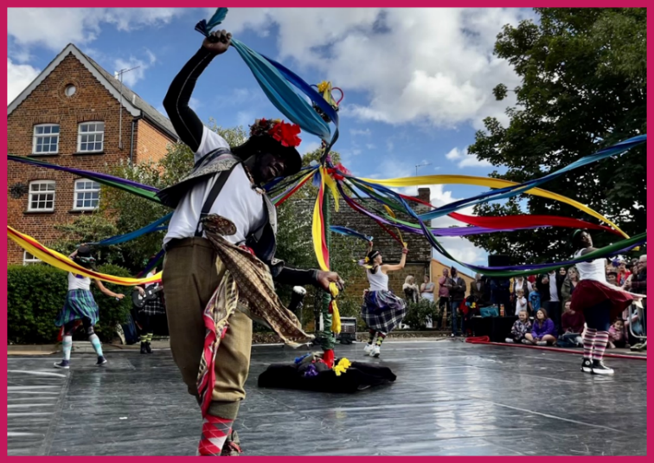

**OUR MISSION & VALUES**

The Mill aims to be the cultural heart of Banbury and beyond. Proudly celebrating a diverse creative programme of high-quality arts experiences; telling stories that encourage everyone in our communities to learn and take part; to have fun and be inspired.

We want to be an exemplar, vibrant, indispensable Arts Centre of which Banbury is rightly proud; relevant to the whole community through a diverse programme which celebrates both taking part in and seeing first class arts and entertainment experiences.

We are much more than just a building, we will work throughout the region to support artists to create and present the highest quality arts experiences.

**Our core values are:**

* Heart and Trust
* For All
* Quality
* Creativity
* Bold and Forward Thinking

**To achieve our aims, we offer three strands of work:**

* Live events including theatre, dance, music and comedy.
* Participatory workshops, events and experiences including performing arts, visual arts and craft and holistic wellbeing.
* Visual art exhibitions.

## **ABOUT THE ROLE**

**Post:** Programme Administrator

**Reporting to:** Programme & Marketing Manager

**Contract:** Permanent 0.6FTE (24 hours per week)

**Working hours:** Regular working pattern to be agreed within the hours 9am-5pm Monday-Friday. Occasional out of hours work as required. We are happy to discuss different working patterns including school hours, three 8-hour days, four 6-hour days etc.

**Salary:** £25,210.20 FTE (£15,126.12 at 0.6FTE)

**Holidays:** 22 days per year FTE (13.25 pro rata) plus public holidays

**Place of work:** The Mill Arts Centre plus occasional offsite meetings and events

## **PURPOSE OF THE POST**

The Programme Administrator will support the effective and efficient running of the Programming, Marketing & Sales functions. Acting as first point of contact for enquiries, ensuring accurate set up and documentation of arrangements, and effective communication across the venue team.

## **JOB DESCRIPTION**

**Key Responsibilities:**

* Act as a first point of contact for artist enquiries, drafting and issuing contracts and deal memos to visiting companies as directed by the Programme & Marketing Manager and maintaining an up-to-date database of communications
* Accurate set up and cross-checking of new events on Spektrix (CRM) and The Mill’s website to include promotional offers where required, and in line with agreed on-sale schedules
* With the support of the Programme & Marketing Manager, process show settlements after the event and maintain the database of show settlements, including compiling final sales reports and processing invoices using Sage
* Check new membership sales and renewals on a weekly basis and issue membership card packs as required
* Monitor the schools & groups email address and process group bookings requests as required including raising customer invoices
* Process sales reports, guest lists and complimentary tickets for visiting companies and the management of ticket allocations for ticket agents as required
* Using Arts Council England’s platform Illuminate, maintain an accurate record of NPO-funded activity and issue post-event surveys using DotDigital
* Liaise with other departments to communicate any specific requirements from visiting companies (e.g. riders, room layouts, merchandise) and linking visiting companies with relevant departments (e.g. Technical, Operations)
* Liaise with visiting companies to maintain accurate records of performance information for all events e.g. age restrictions, running times etc, and ensure this is communicated to the relevant departments internally
* Maintain accurate records of outstanding payments for creative courses where customers have paid by instalments, and contact customers to take outstanding payments when due
* Regularly review house, company, agency and access seats & liaise with companies and the Operations team to ensure timely release of unused allocations
* Act as a key liaison with visiting artists to obtain adequate print and digital marketing assets and maintain an up-to-date database of marketing assets held
* Assist the Programme & Marketing Manager with programming live event bookings e.g. fielding enquiries, researching performances and production companies, and initial discussions
* Assist the Marketing & Development Officer with day-to-day website updates and ensuring The Mill’s event listings are up-to-date
* Support the Programme & Marketing Manager and Marketing & Development Officer with press and publicity activity including event listings on external sites, social media updates and sending out press releases etc
* Assist the Marketing & Development Officer with refreshing print in the building and in local businesses
* Support the collation of data required for reporting to PRS (Performing Right Society) by maintaining an accurate record of relevant show details
* Occasionally represent and promote The Mill as part of the team at key events e.g. Banbury Canal Festival

**General**

* Uphold all organisational values, policies and procedures, promoting those specifically relevant to the scope of the role such as Equality & Diversity, Access, GDPR, Child Protection and Health & Safety
* Undertake training as deemed necessary to support ongoing effective performance in the role
* Attend performances both at The Mill and off site when required to maintain up to date and effective product knowledge, support audience development activity and generate social media content as directed by the Programme & Marketing Manager or Marketing & Development Officer.

*This job description is a guide to the general nature of the work required. It is not wholly comprehensive or restrictive and can be reviewed at any time.*

## **PERSON SPECIFICATION**

|  |  |
| --- | --- |
| **ESSENTIAL** | **DESIRABLE** |
| A genuine commitment to broadening access to the arts for all, respecting all within our communities and their needs | Previous experience of the Spektrix CRM system |
| Evident passion for the arts and the vision and values of The Mill Arts Centre | Prior experience in a similar arts administrator role or relevant qualification |
| Excellent administrative and organisational skills | Prior experience of website maintenance (WordPress) |
| High standards of numeracy and computer literacy | Prior experience of managing professional social media platforms |
| Meticulous standards of attention to detail | Previous experience of using Sage |
| Excellent time and workload management with the ability to work to deadlines | Previous experience of using email platform DotDigital and/or Arts Council England platform Illuminate |
| Confident and professional manner both in person and on the phone | Full clean driving licence |
| Collaborative approach to team working with a positive and forward-thinking attitude to support the wellbeing of others |  |
| Evidence of ability to work effectively with a wide range of people and organisations to build positive relationships |  |
| Self-motivated with the ability to work unsupervised |  |

## **HOW TO APPLY**

Please apply by sending the following to Sarah Wright, Programme & Marketing Manager ([sarah.wright@themillartscentre.co.uk](mailto:sarah.wright@themillartscentre.co.uk)) by **9am on Tuesday 7th January 2025**:

* a completed [application form](https://www.themillartscentre.co.uk/wp-content/uploads/2023/02/MACT-Application-Form.doc)
* a cover letter explaining your interest in the position

**Interviews are scheduled to take place at The Mill on Tuesday 14th January 2025, or as soon as possible thereafter.**

If you have any questions or require assistance, please contact [sarah.wright@themillartscentre.co.uk](mailto:sarah.wright@themillartscentre.co.uk). Good luck!